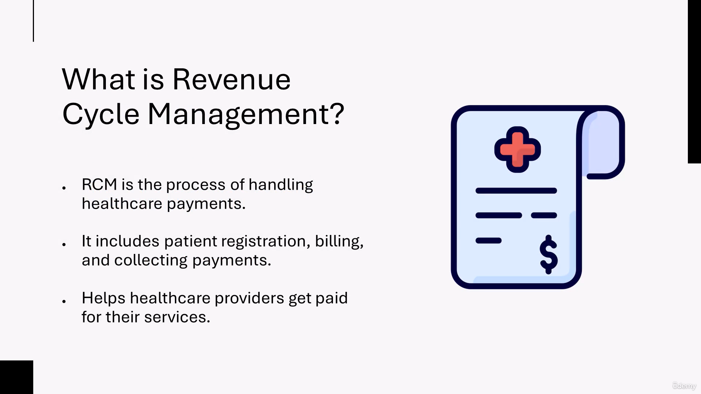

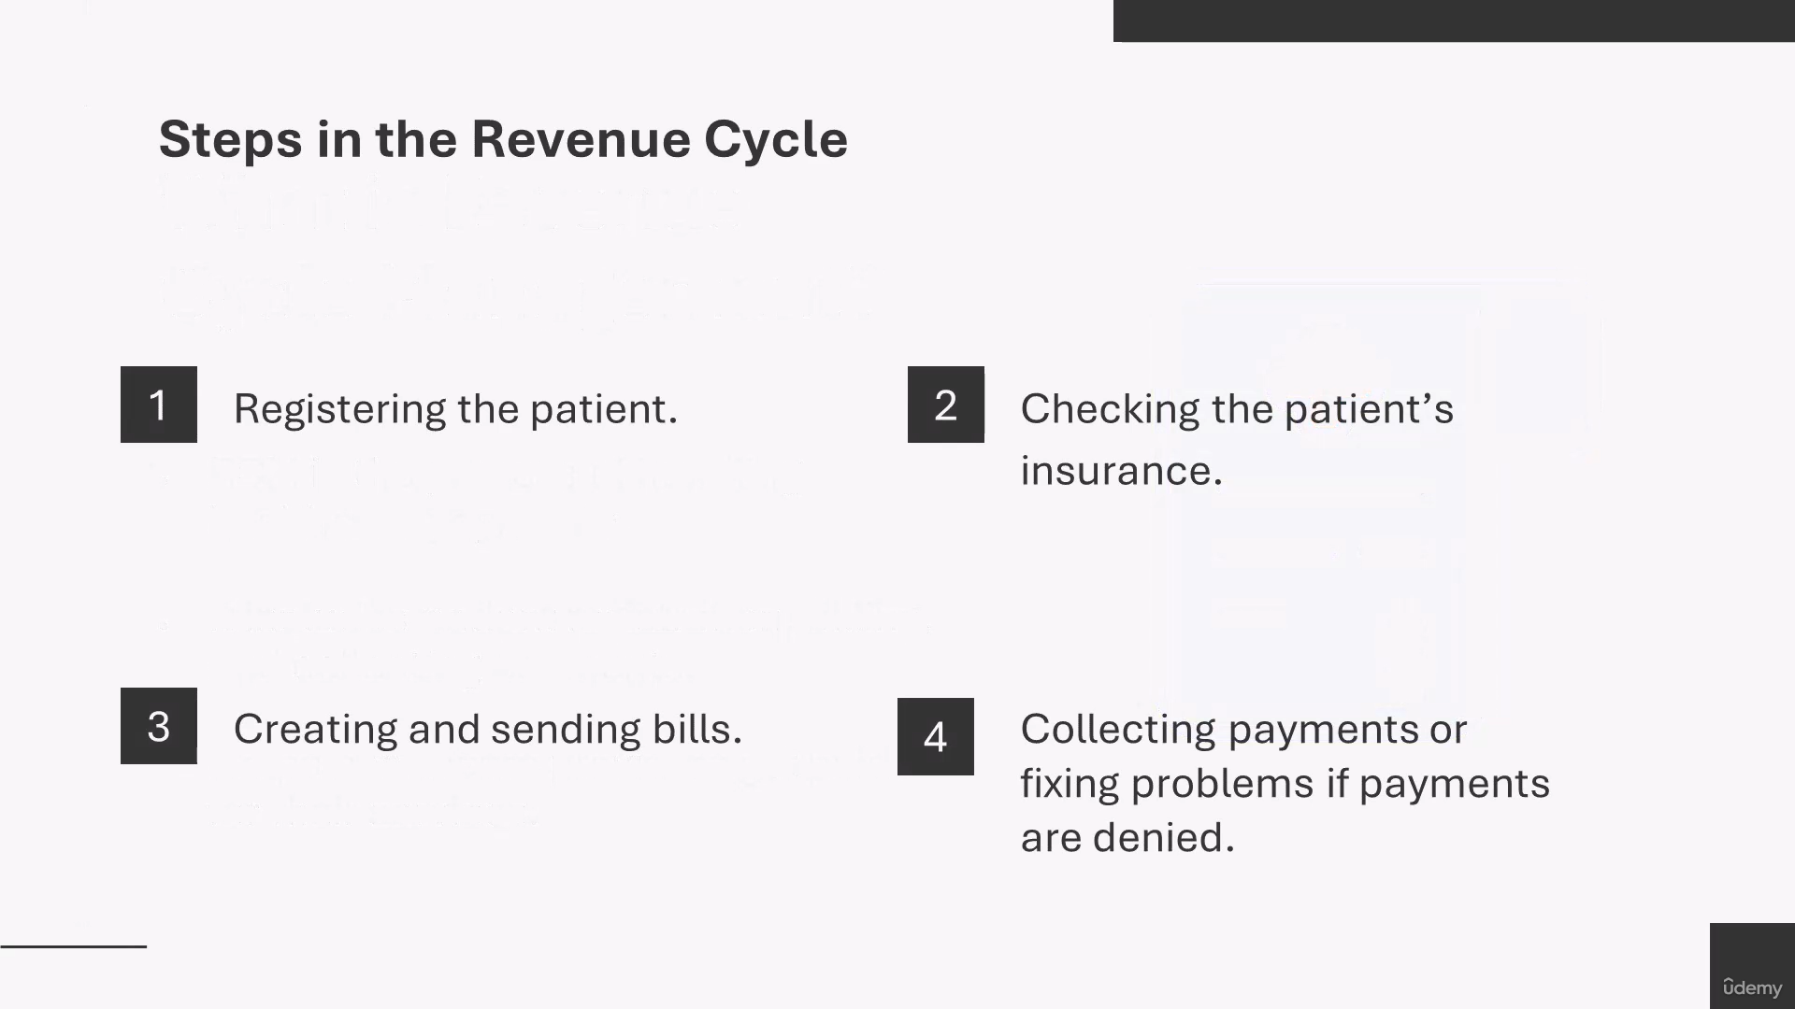
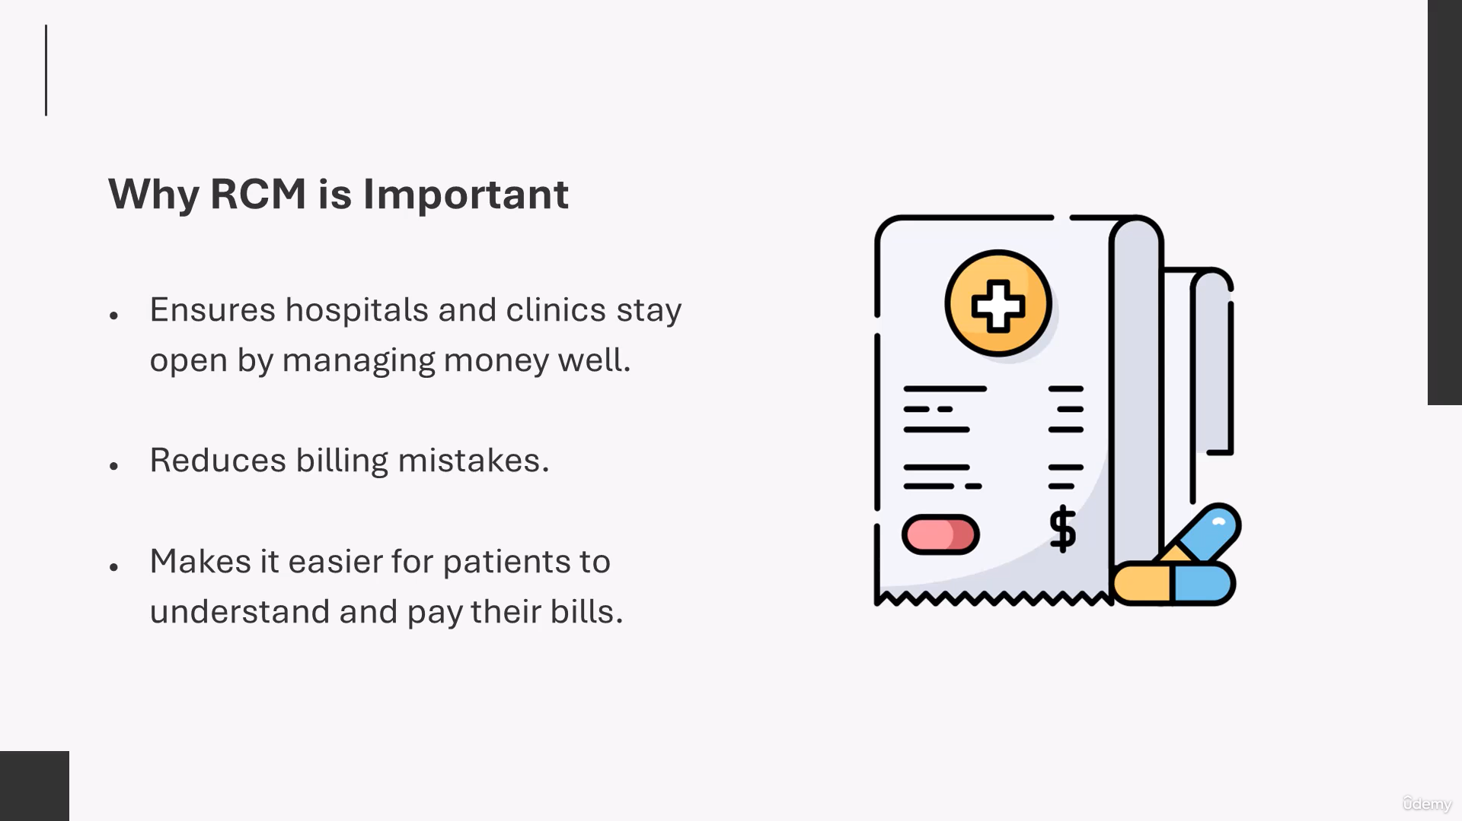


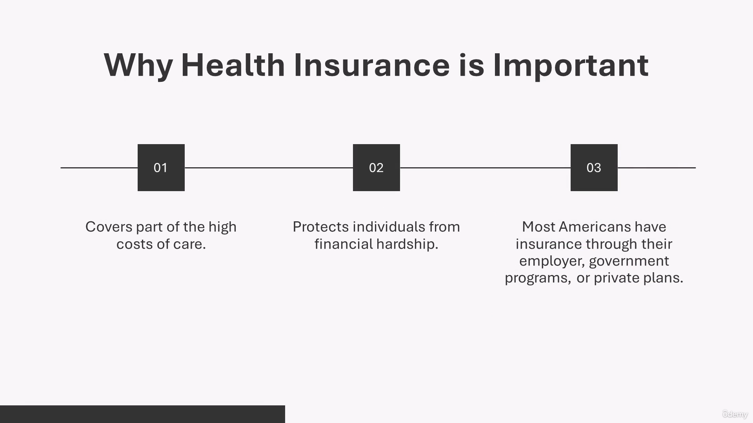
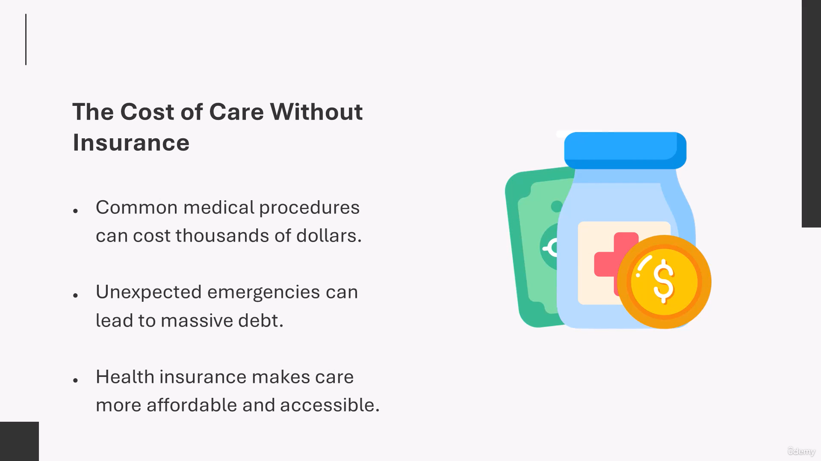
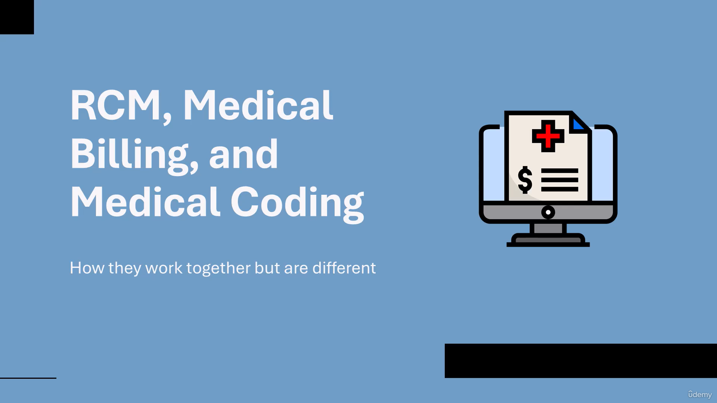
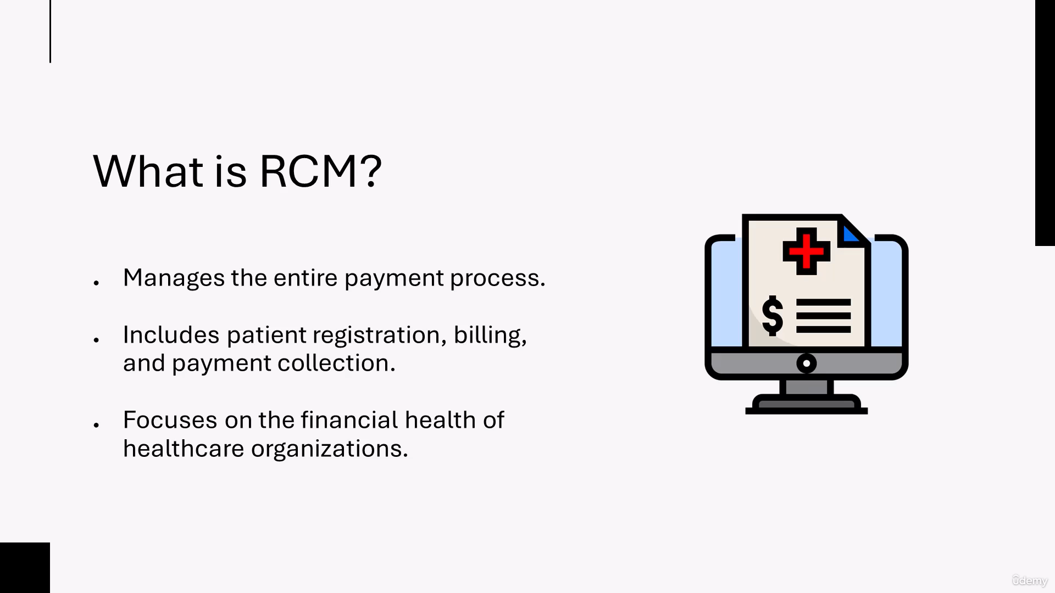
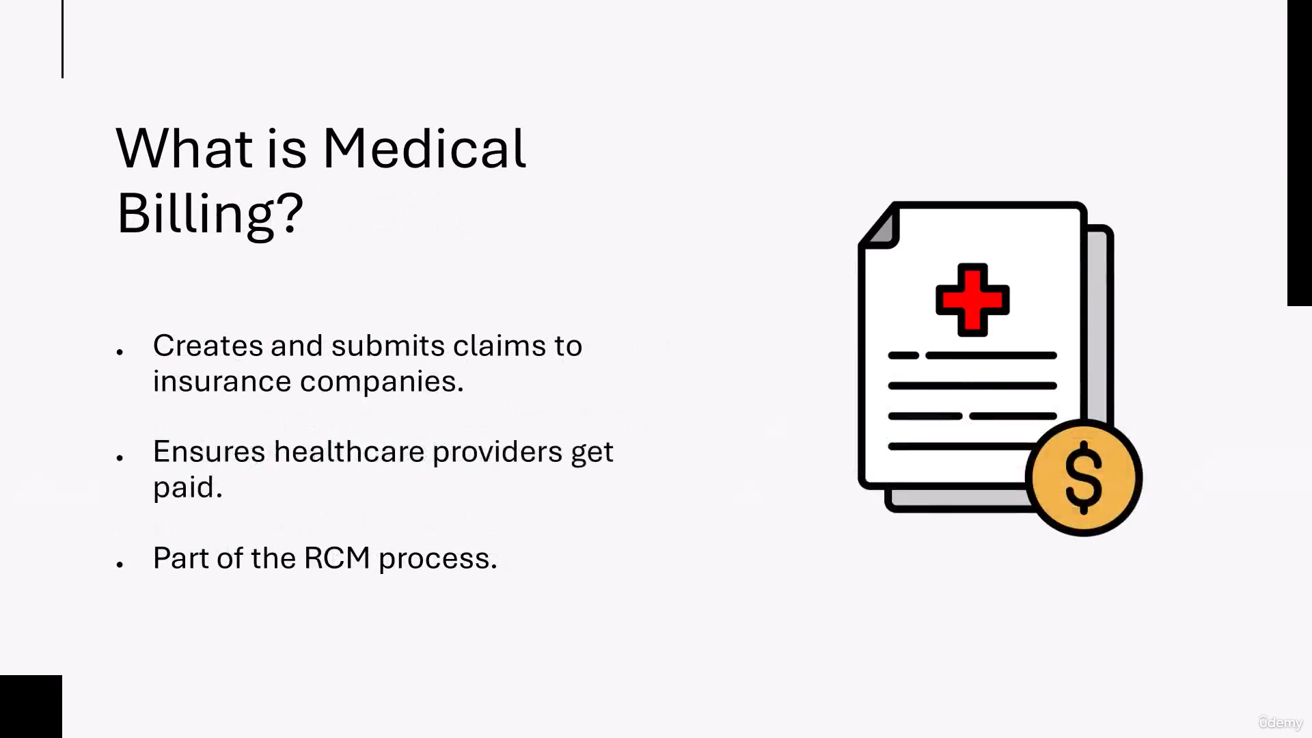

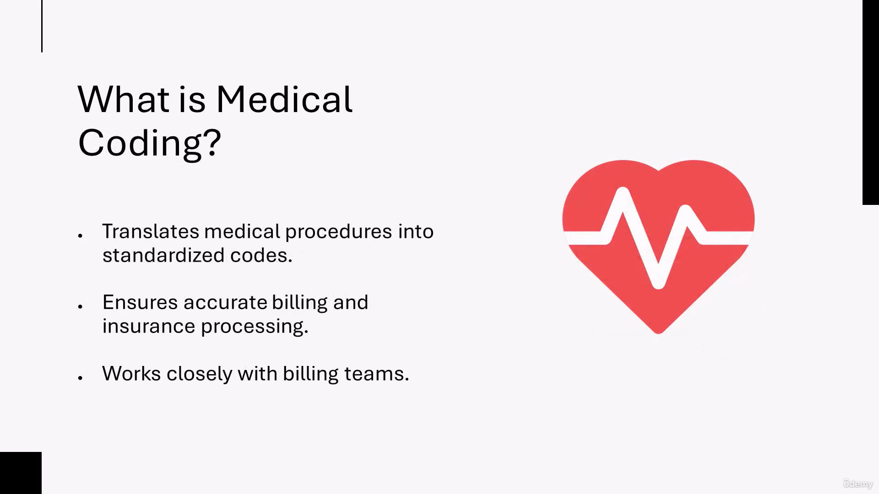
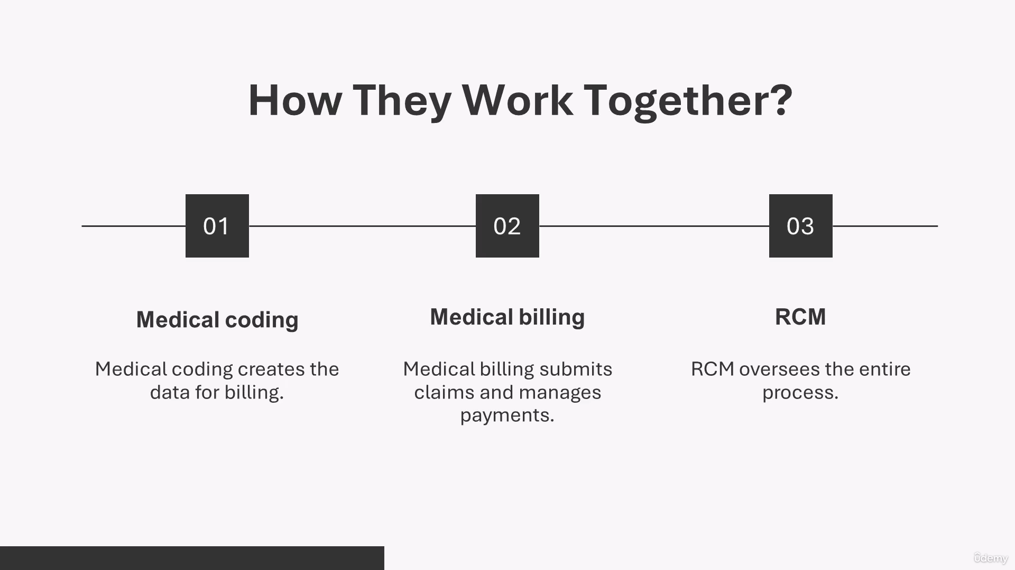
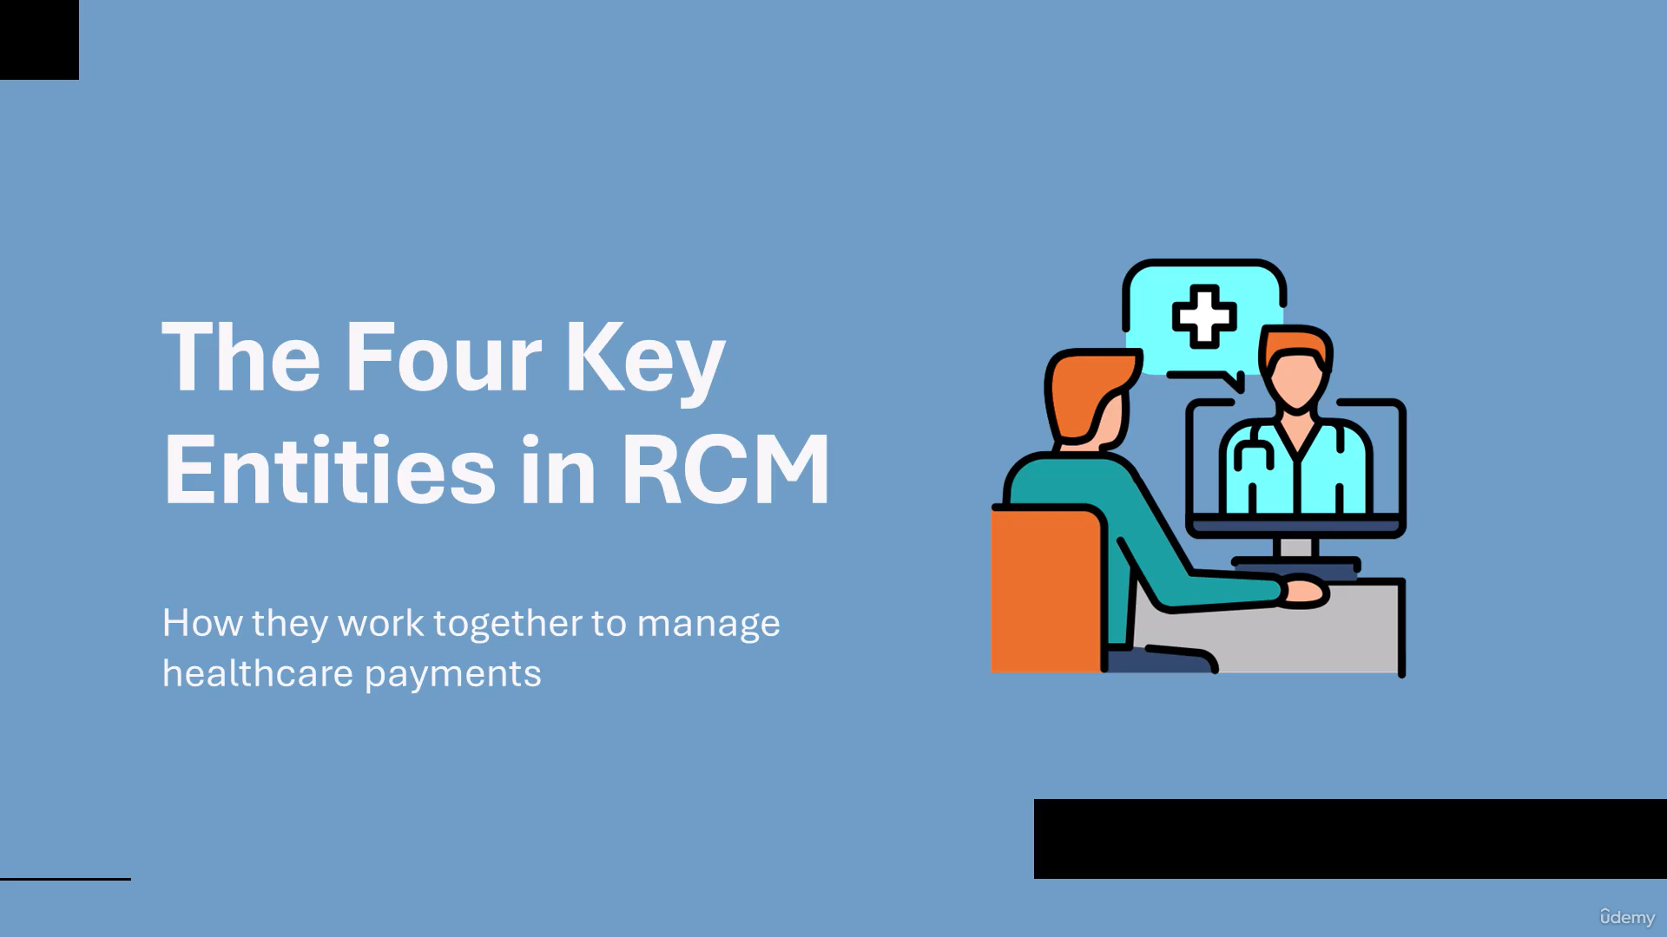

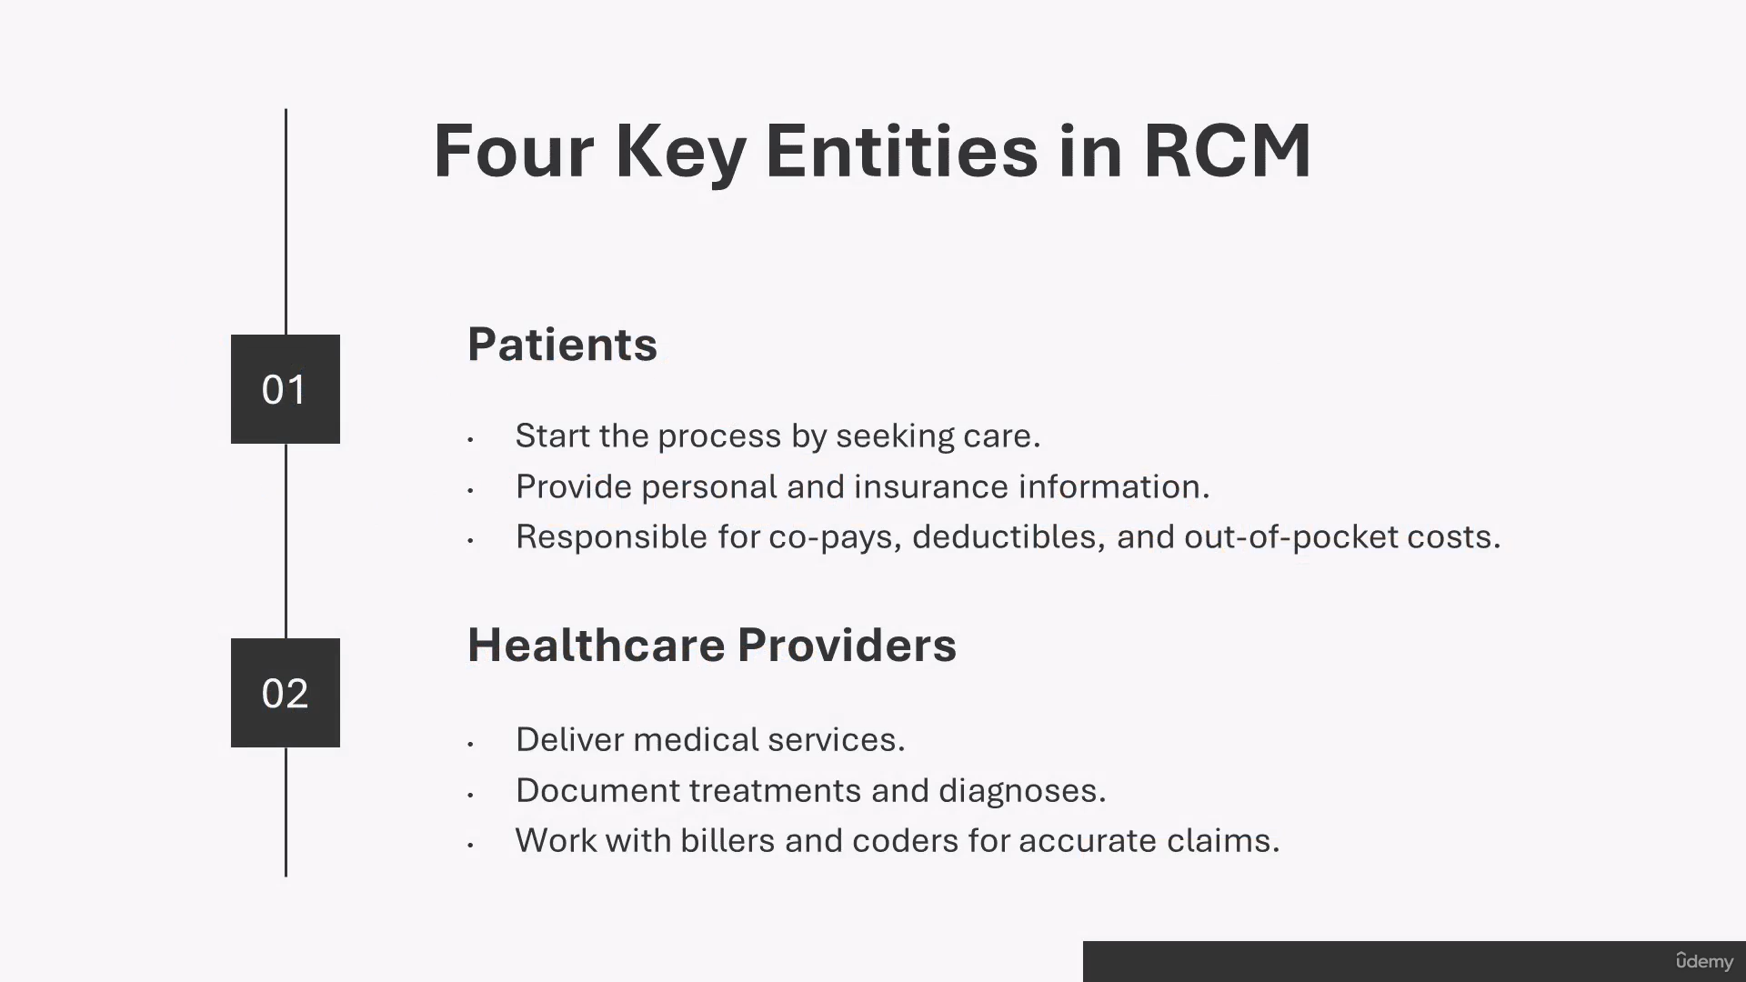
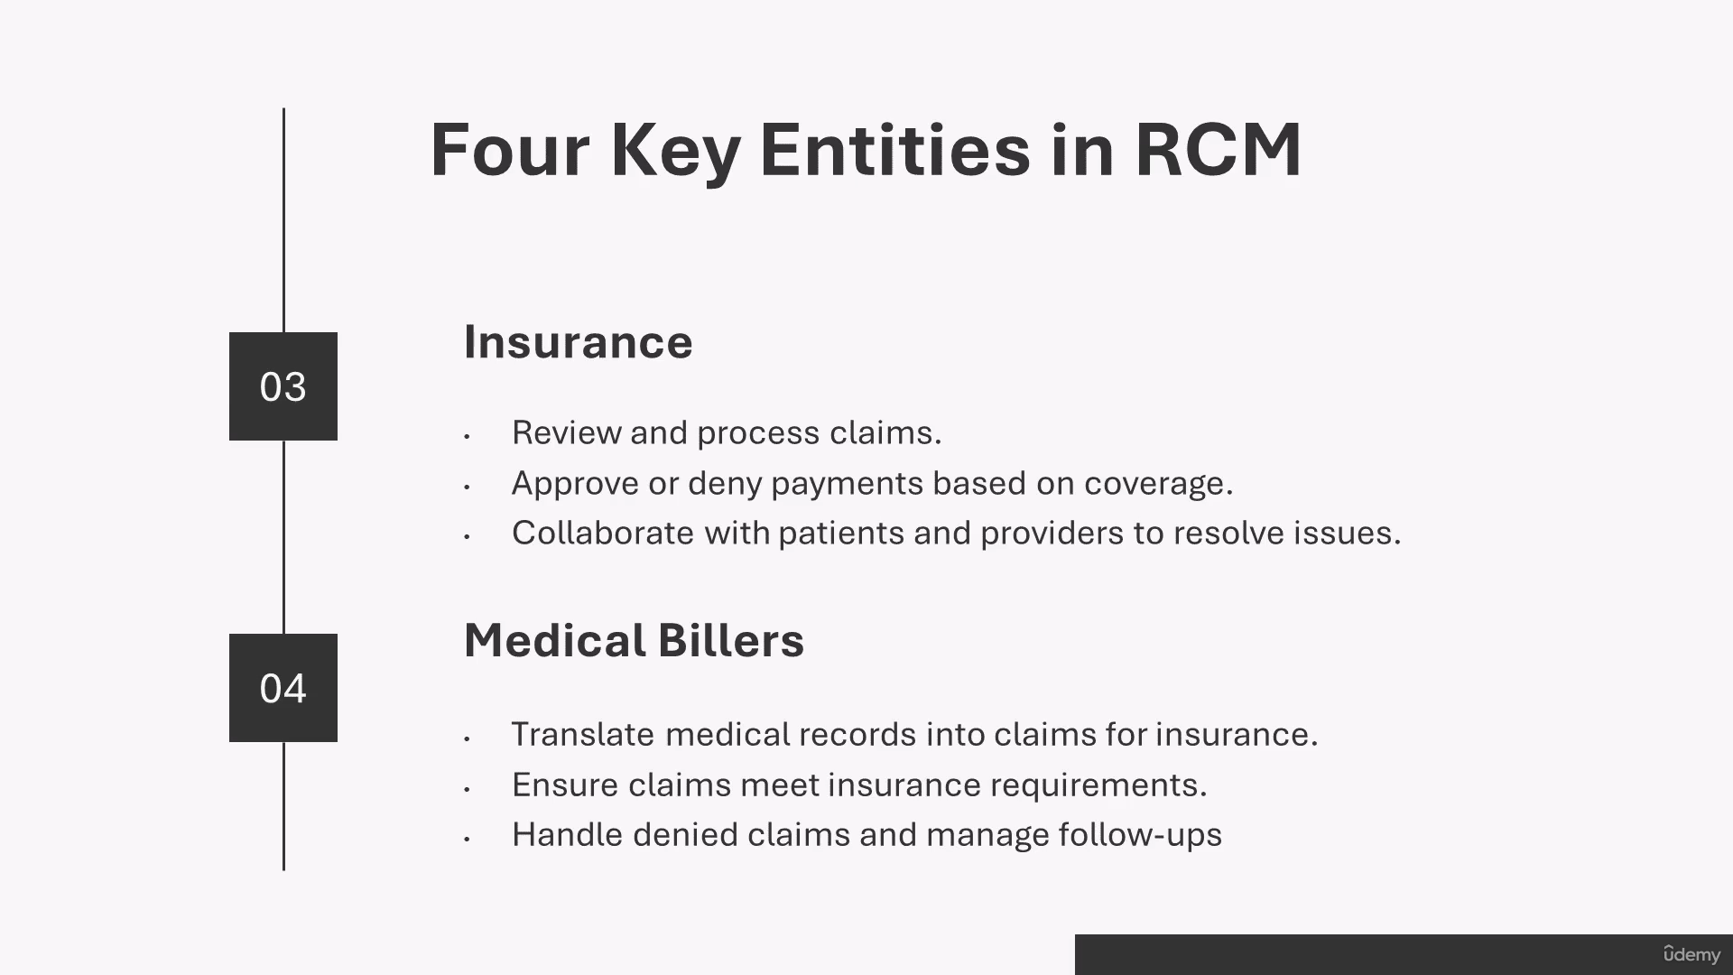
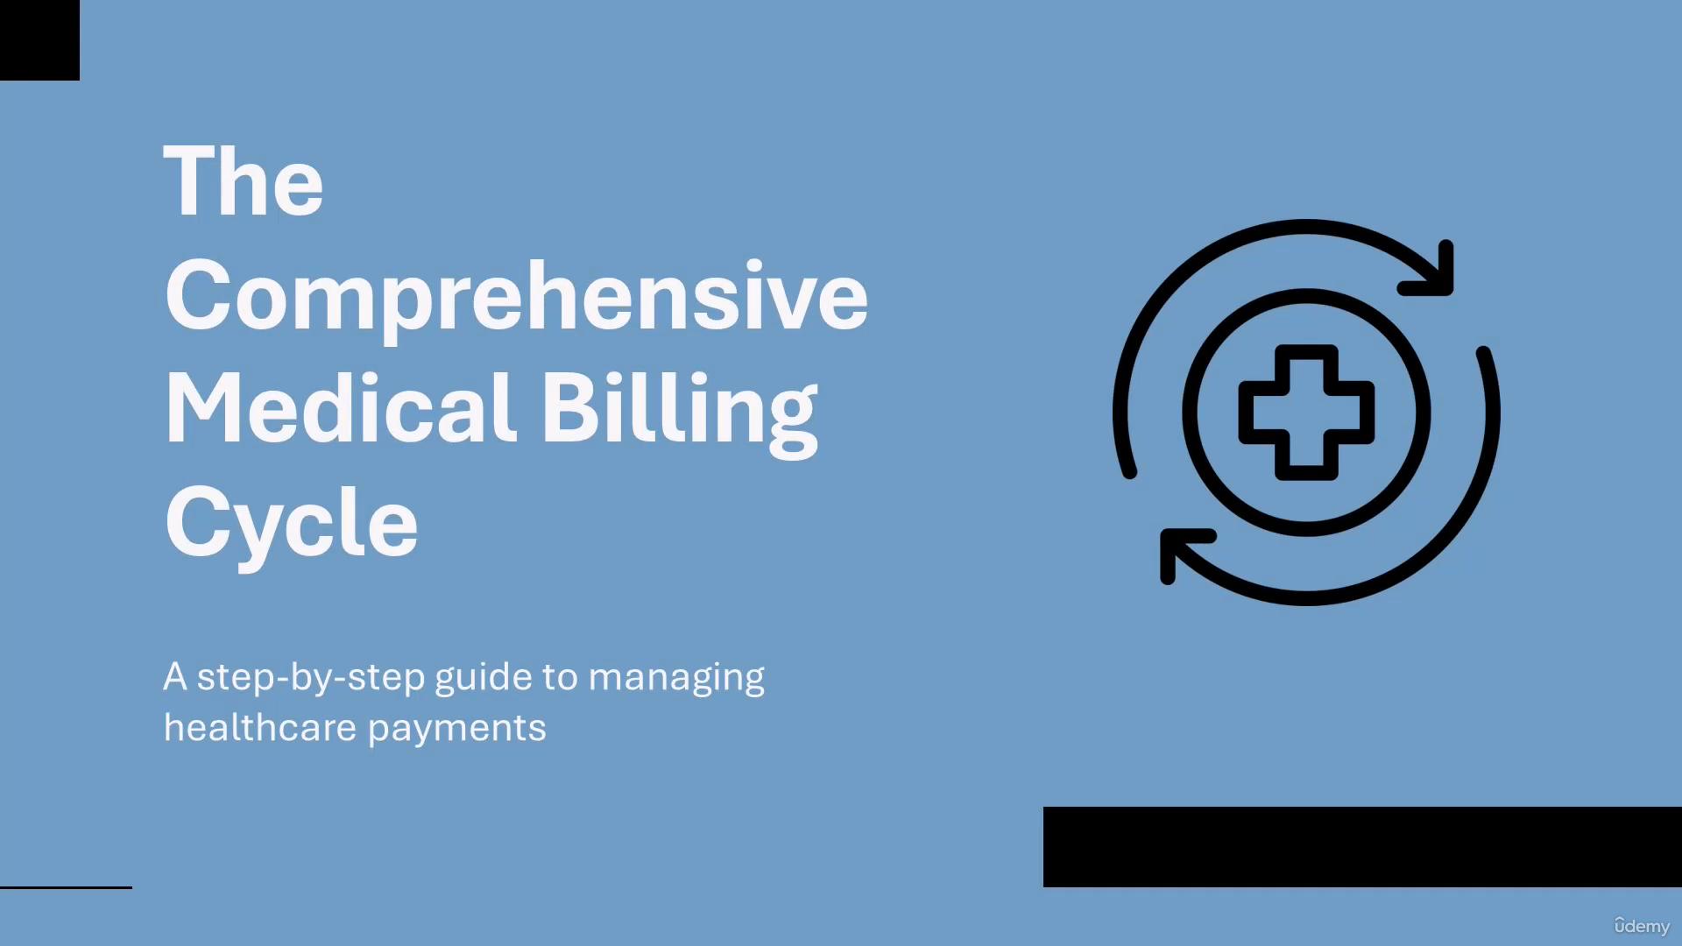
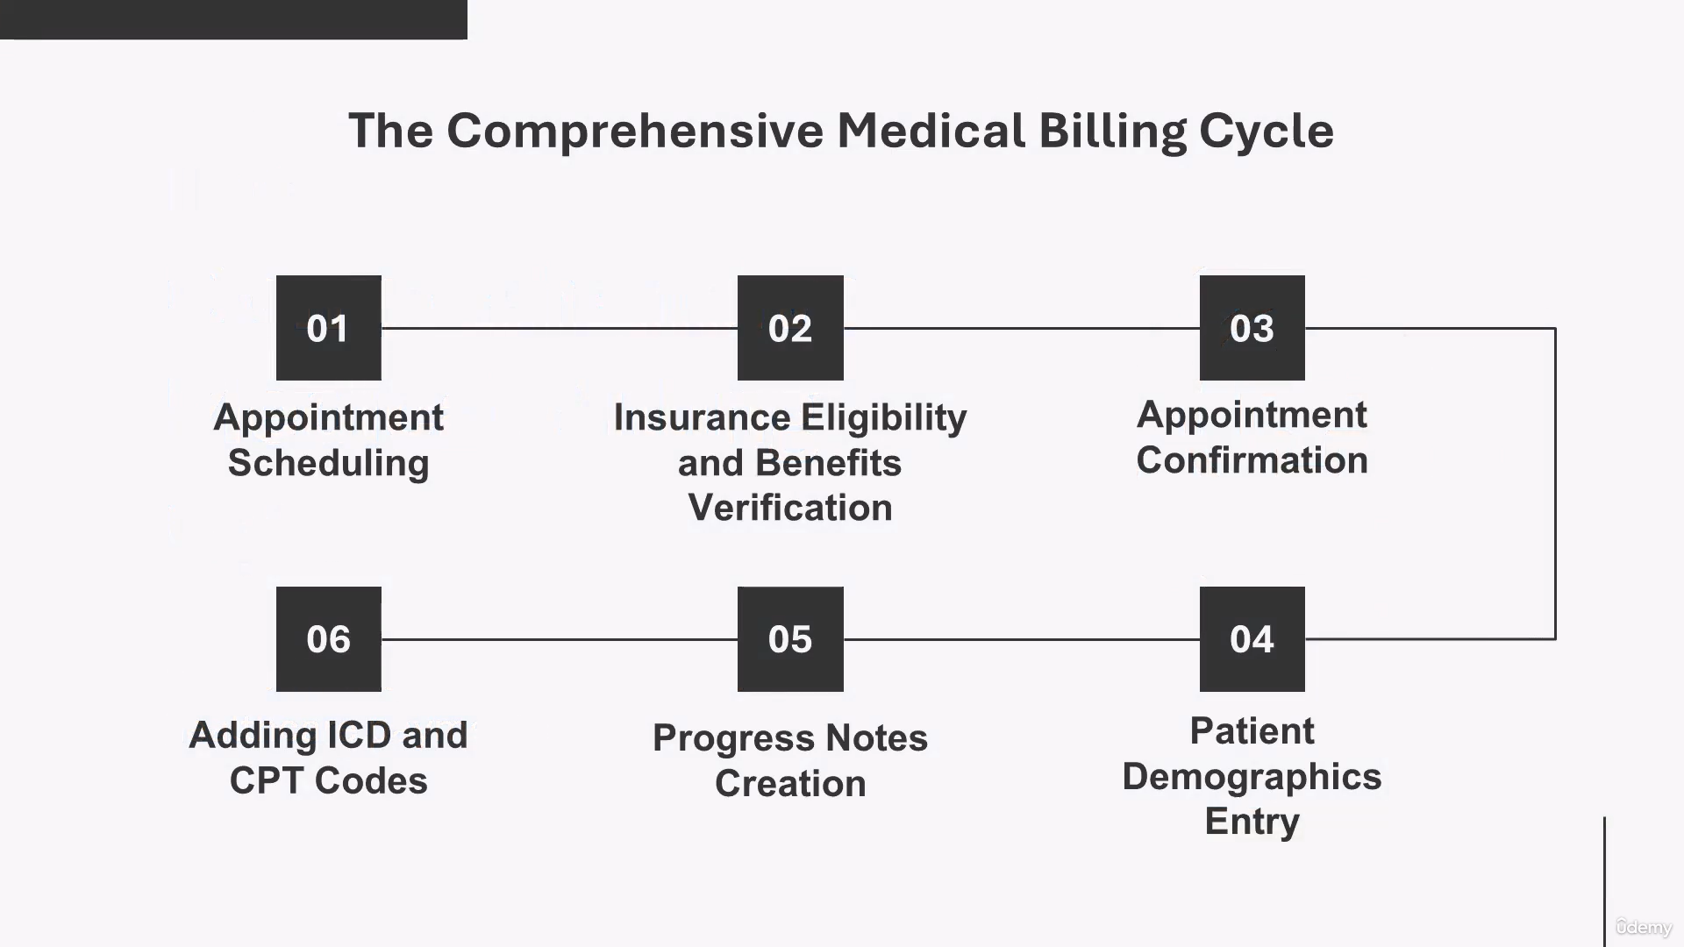
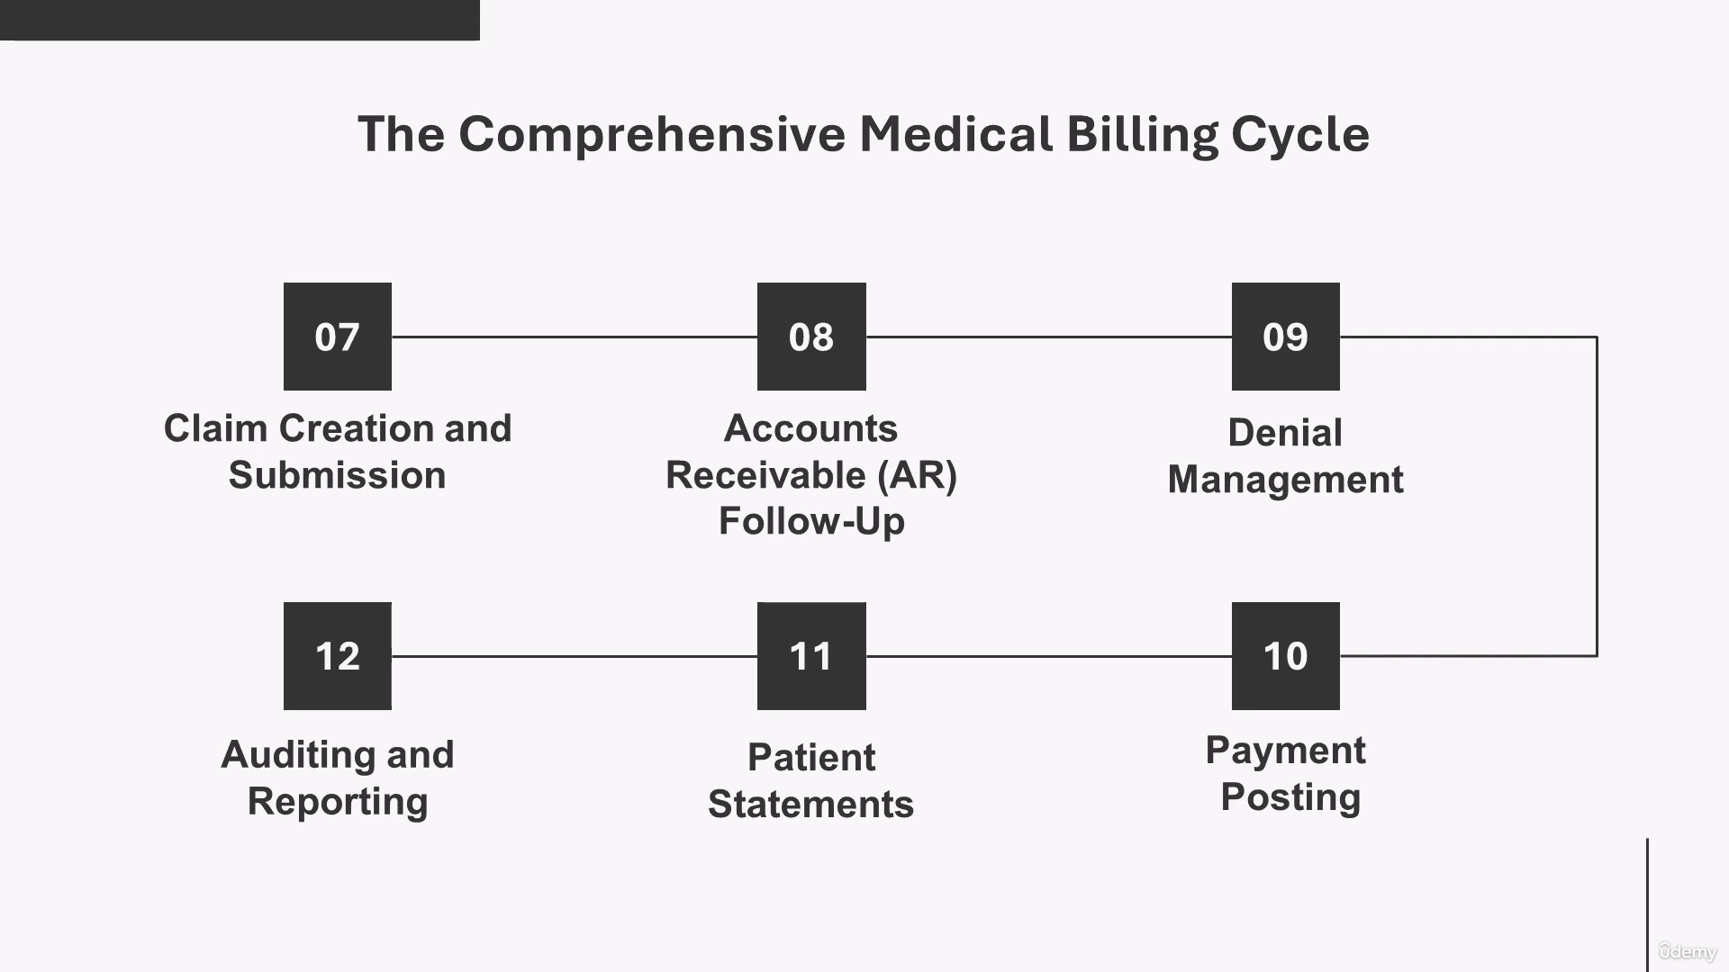
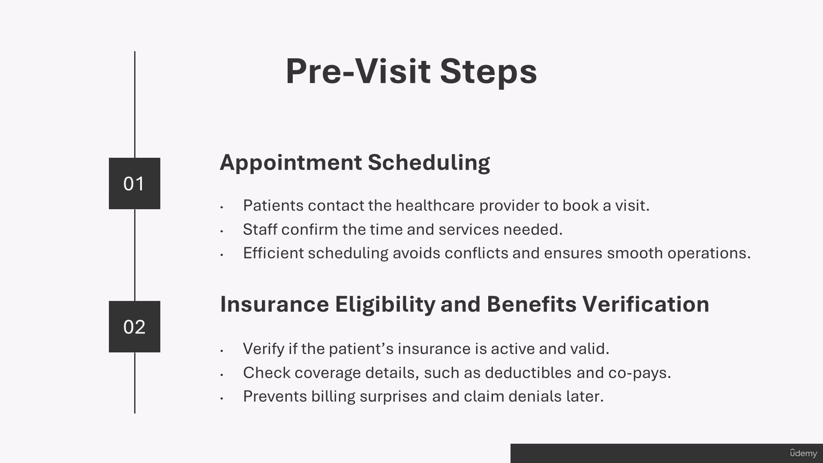

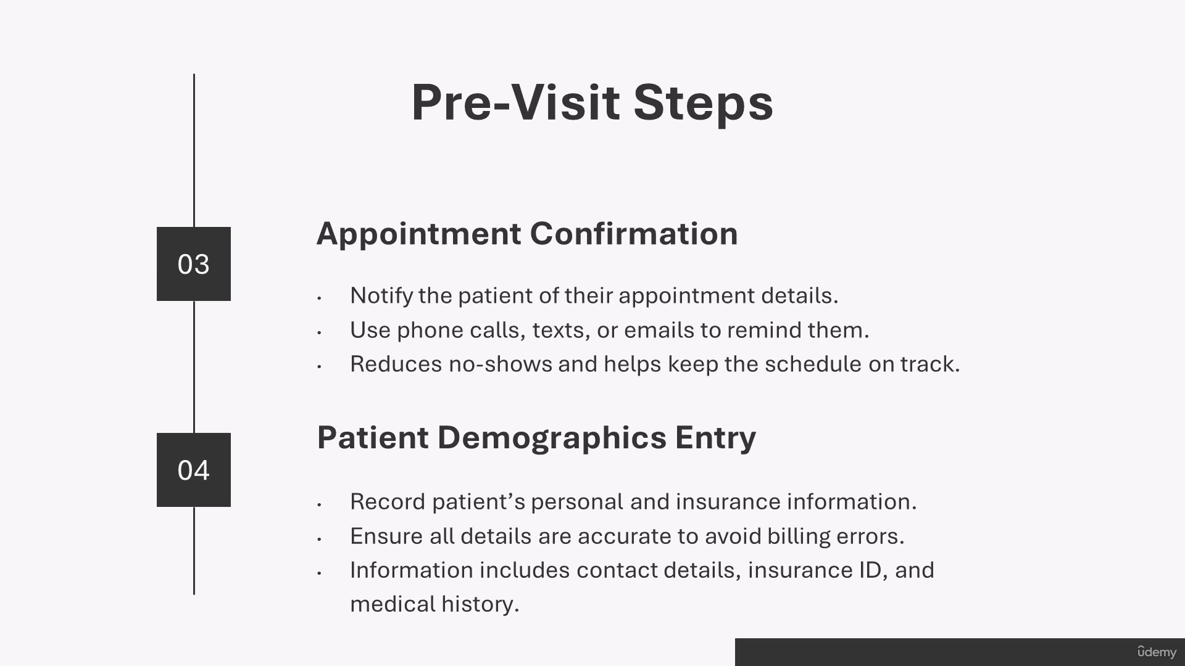

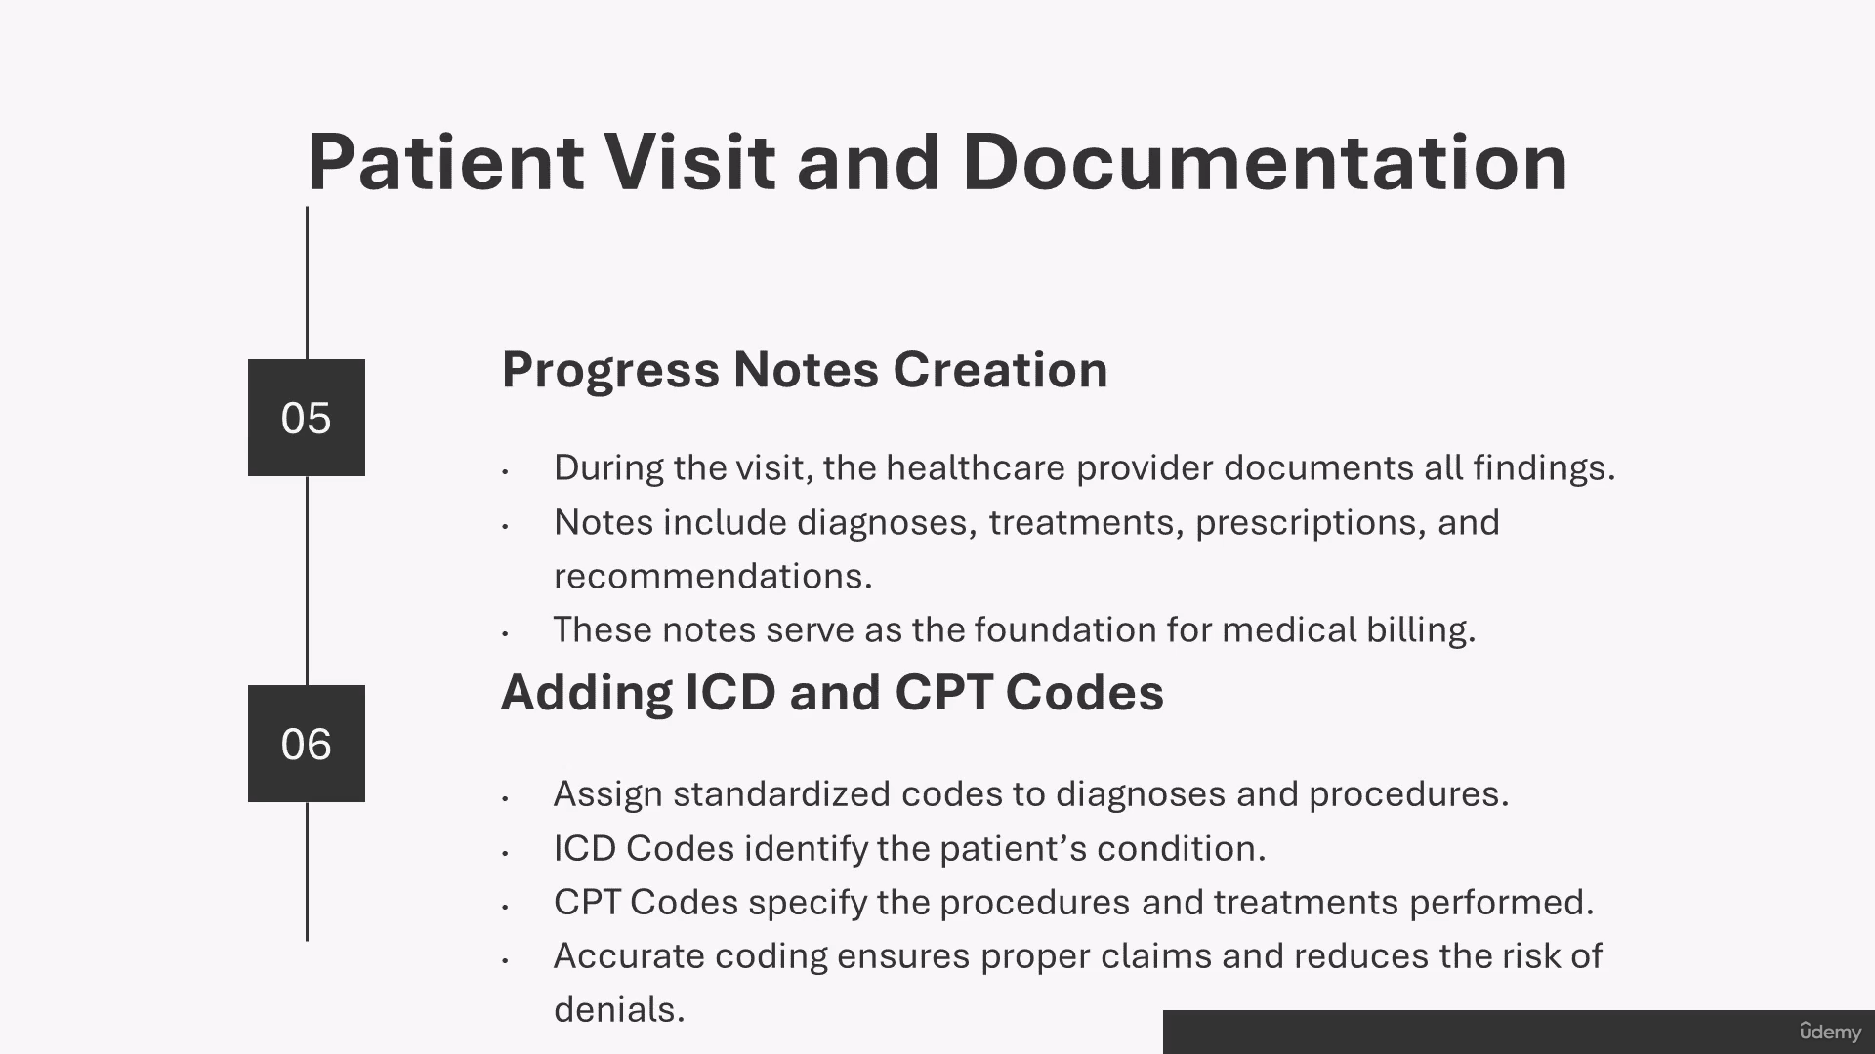
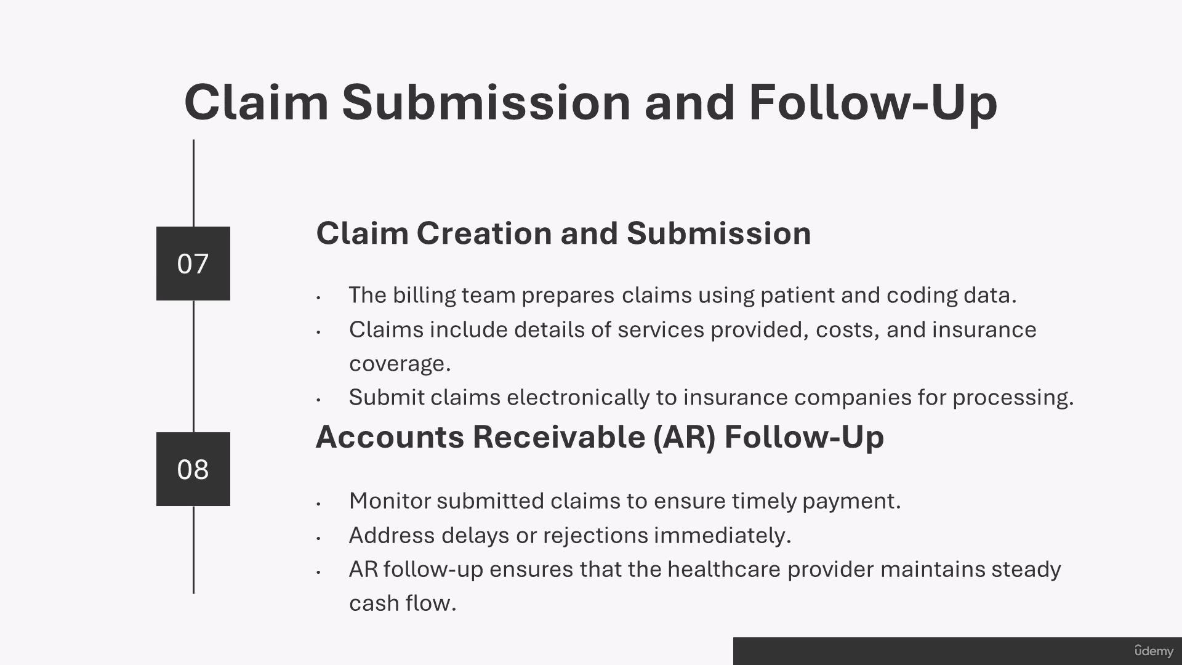

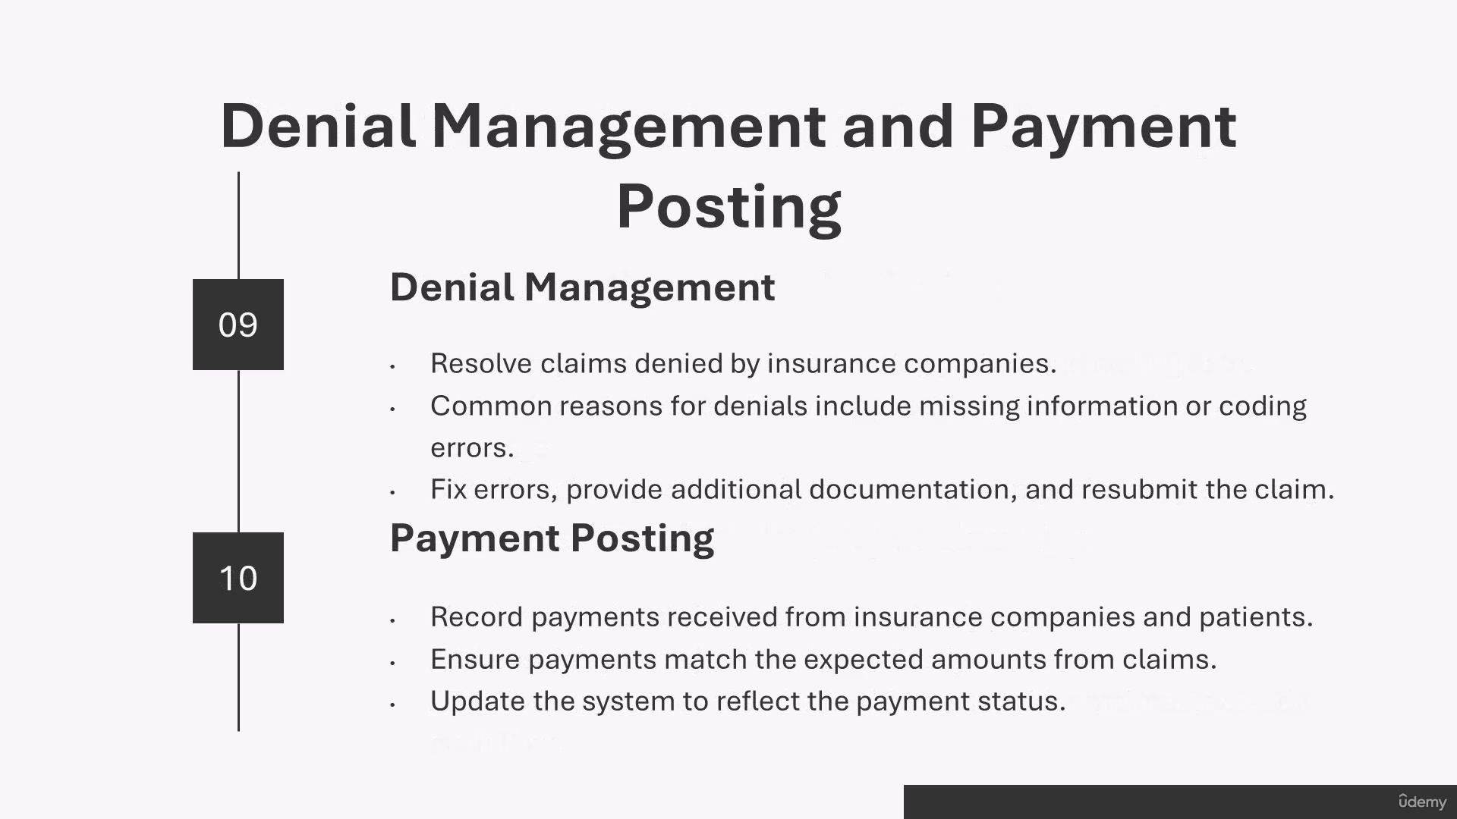
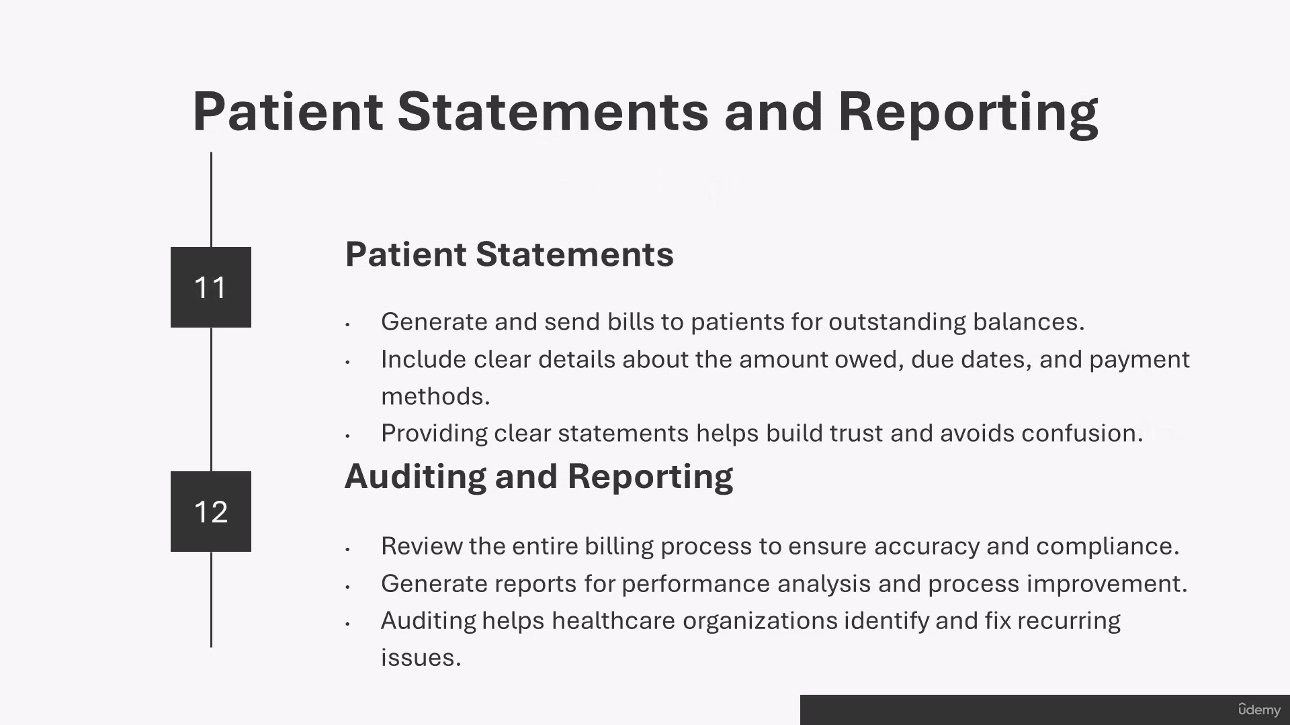
1. Patient Registration:
- Get: Name, DOB, address, insurance info
- Provider starts building claim (called "charge")
2. Insurance Verification:
- Check: Is insurance active?
- Verify: What services are covered?
- Prevent: Unexpected costs for patient
3. Medical Coding:
- Doctor documents: Symptoms, diagnosis, treatment
- Coder assigns: ICD-10, CPT, HCPCS codes
- Purpose: Standardize info for insurance processing
4. Claim Submission:
- Bill includes: All visit details, services, costs
- Sent to: Insurance company (payer)
- Monitor: Accepted, rejected, or denied
5. Insurance Payment or Denial:
- Insurance checks: Complete info? Matches records?
- If error: Claim rejected - submit corrected claim
- If approved: Insurance pays portion
- If denied: Provider investigates - resubmit or appeal
- Patient gets: EOB explaining what's covered
6. Patient Payment:
- Provider sends: Statement for patient's portion
- Patient pays: Balance owed (copay, deductible, coinsurance)
- Options: Full payment or payment plan

